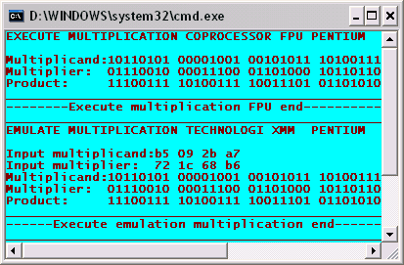
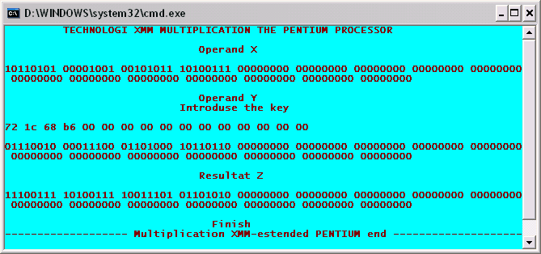
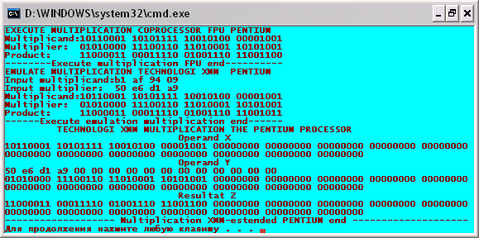

EXECUTE MULTIPLICATION COPROCESSOR FPU PENTIUM
Multiplicand:10110001 10101111 10010100 00001001
Multiplier: 01010000 11100110 11010001 10101001
Product: 11000011 00011110 01001110 11001100
--------Execute multiplication FPU end----------
EMULATE MULTIPLICATION TECHNOLOGY XMM PENTIUM
Input multiplicand:b1 af 94 09
Input multiplier: 50 e6 d1 a9
Multiplicand:10110001 10101111 10010100 00001001
Multiplier: 01010000 11100110 11010001 10101001
Product: 11000011 00011110 01001110 11001011
------Execute emulation multiplication end------
TECHNOLOGI XMM MULTIPLICATION THE PENTIUM PROCESSOR
Operand X
10110001 10101111 10010100 00001001 00000000 00000000 00000000 00000000 00000000 00000000 00000000 00000000 00000000 00000000 00000000 00000000
Operand Y
50 e6 d1 a9 00 00 00 00 00 00 00 00 00 00 00 00
01010000 11100110 11010001 10101001 00000000 00000000 00000000 00000000 00000000 00000000 00000000 00000000 00000000 00000000 00000000 00000000
Resultat Z
11000011 00011110 01001110 11001100 00000000 00000000 00000000 00000000 00000000 00000000 00000000 00000000 00000000 00000000 00000000 00000000
------------------- Multiplication XMM-estended PENTIUM end --------------------
Для продолжения нажмите любую клавишу . . .

